**TDI EXCEL CAPSTONE PROJECT – ESG & FINANCIAL PERFORMANCE ANALYSIS**

***By Felicitas Ezechikeluba***

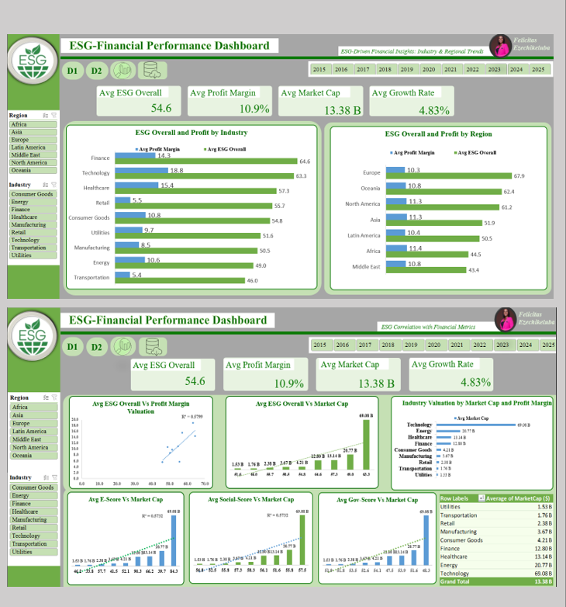

**OVERVIEW**

This project explores the relationship between Environmental, Social, and Governance (ESG) scores and key financial metrics across 1,000 publicly traded companies globally (2015–2025). It aims to uncover patterns to guide investors toward sustainable and high-performing companies by industry and region.

**ABSTRACT**

Using data from 1,000 global companies aliased with ID’s, across 7 regions of the world, this analysis investigates how ESG performance correlates with financial metrics like profit margin and market capitalization. The project focuses on identifying ESG pillars that most influence financial success, uncovering industry/regional patterns, and guiding investment decisions through interactive Excel dashboards. The analysis includes data cleaning, transformation, pivot tables, and visual storytelling through KPIs and charts.

**PROJECT BACKGROUND**

ESG stands for ***Environmental***, ***Social***, and ***Governance***, a framework for evaluating how sustainable and responsible a company is beyond financial results. As stakeholders demand responsible business practices, ESG data is increasingly used to judge long-term potential.

**Environmental**: Impact on nature (emissions, energy, waste)

→ Carbon emissions, energy use, waste management, water conservation.

→ Risk Example: Carbon taxes or climate regulations.

→ Opportunity: Cost savings from energy efficiency or green innovation.

**Social**: Treatment of people (employees, customers, communities)

→ Labor practices, diversity, health and safety, data privacy.

→ Risk Example: Strikes or consumer boycotts.

→ Opportunity: Higher employee retention, brand loyalty.

**Governance:** How the company is managed (ethics, board, compliance)

→ Board diversity, executive pay, shareholder rights, transparency.

→ Risk Example: Fraud, corruption, poor board oversight.

→ Opportunity: Strong governance attracts capital and trust.

Investors, consumers, and regulators increasingly use ESG metrics to assess long-term value and risk. However, the direct link between ESG performance and financial outcomes remains underexplored.

**Why ESG Matters**

* Investors rely on ESG scores to identify sustainable, lower-risk investment opportunities and Industries.
* Stakeholders view strong ESG performance as an indicator of long-term value, ethical governance, and social responsibility.

While ESG data is widely available, its direct link to financial performance is often unclear or underutilized. Investors and stakeholders need a clearer understanding of:

* Which ESG pillars (Environmental, Social, Governance) drive the most value.
* Which industries or regions lead or lag in ESG performance.
* Whether high ESG scores translate into strong financial outcomes.

This project analyzes 1,000 publicly traded global companies (market cap > $1B) from 2015–2025 across 7 regions to uncover how ESG performance relates to profit margins, market value, and growth potential. The goal is to provide clear, data-driven insights that support smarter, sustainable investment decisions.

**PROJECT OBJECTIVES**

This project focuses on the financial relevance of ESG data, especially in guiding sustainable investments across industries and regions, and it will clearly define how ESG factors relate to company financials. This includes:

• Identifying high- and low-performing companies from an ESG perspective.

• Investigating which ESG pillars (Environmental, Social, Governance) most strongly correlate with financial success.

• Recognizing industry or regional patterns in ESG scores and performance metrics.

**PROBLEM STATEMENT**

Do companies with higher ESG scores perform better and have more market value across industries?

**Business Questions**

This analysis will focus on answering the following 5 key questions:

1. What is the Correlation between Overall ESG scores with key financial metrics like profit margin and Market cap?
2. Which ESG factor (Environmental, Social, or Governance) has the strongest link to profit margin and market value?
3. What are the Top Performing Industries in the Global Market
4. Which industries have the best combination of high ESG scores and strong financial performance?
5. Which region has the best combination of high ESG scores and strong financial performance?

**SCOPE OF WORK**

To solve the challenge, the project will involve:

* Cleaning and transforming ESG and financial datasets for analysis.
* Aggregating the data using pivot tables
* Visualizing key findings in an interactive Excel dashboard.
* Producing insights that support sustainable investment strategies.

**EXPECTED OUTCOMES**

* Identification of patterns between ESG pillars and financial success.
* Visual dashboards to support stakeholder decision-making.
* Documentation to ensure transparency and replicability of findings.
* Actionable recommendations for policy and investment strategy.

**METHODOLOGY**

**-** Tools: Excel

**-** Steps: Data cleaning → Pivot Analysis → Visual Dashboard Design

**-** Output: Interactive Excel dashboard with 2 pages of grouped insights answering 5 core business questions.

**GOALS**

To determine how ESG metrics influence profitability and investor perception across industries and regions.

**OBJECTIVES**

- Understand correlations between ESG scores and profit margin/market cap

- Identify which ESG pillar most strongly predicts financial outcomes

- Highlight industry and regional ESG-financial performance patterns

- Present findings through an interactive dashboard

**KEY FOCUS AREAS**

- ESG scores: Overall, Environmental, Social, Governance Scores

- Financial metrics: Profit Margin, Market Cap

- Aggregated patterns by industry and region

- Investment-focused decision insights

**DATA DESCRIPTION**

**Project Materials**

- Excel dataset of 1,000 companies

- ESG + Financial data (2015–2025)

- ESG Data Dictionary

**Data Sources**

- Provided as part of the TDI Capstone Project (Sapphire Cohort)

**Data Characteristics**

- 11,001 rows

- 15 fields, namely:

Company ID, Company Name, Industry, Region, Year, Revenue ($), Profit Margin, Market Cap ($), Growth Rate (%), ESG_Overall (0-100 Scale), ESG_Environmental (0-100 Scale), ESG_Social (0-100 Scale), ESG_Governance (0-100 Scale) , Carbon Emissions (MtCO2e/yr), Water Usage (m³)/year, Energy Consumption (MWh)/year

- Time-series format (2015–2025 for each company)

**Data Overview**

| **Field Name** | **Description** |
| --- | --- |
| **Company ID** | A unique code or number assigned to each company in the dataset. |
| **Company Name** | The aliased name of the company |
| **Industry** | The sector the company belongs to (e.g., Technology, Healthcare, Finance). |
| **Region** | The geographical area or continent the company operates in (e.g., North America, Europe, Asia). |
| **Year** | The specific year for the ESG and financial data (from 2015 to 2025). |
| **Revenue ($)** | Total income generated by the company from its business operations, expressed in dollars. |
| **Profit Margin (%)** | The Profit divided by revenue, expressed as a percentage. It shows how much profit a company makes from its sales. |
| **Market Cap ($)** | The total market value of a company's outstanding shares (share price × number of shares). Reflects the company's value according to investors. |
| **Growth Rate (%)** | How much the company's revenue increased or decreased compared to the previous year, shown as a percentage. |
| **ESG_Overall (0–100 Scale)** | The overall ESG score combining Environmental, Social, and Governance ratings into one value between 0 and 100. |
| **ESG_Environmental (0–100 Scale)** | Measures the company's performance in environmental issues (carbon emissions, resource use, etc.). |
| **ESG_Social (0–100 Scale)** | Measures how the company handles relationships with employees, suppliers, customers, and communities. |
| **ESG_Governance (0–100 Scale)** | Measures the quality of leadership, board structure, company audits, and shareholder rights. |
| **Carbon Emissions (MtCO₂e/year)** | The amount of carbon dioxide emissions generated by the company each year. |
| **Water Usage (m³/year)** | Total amount of water used by the company annually. |
| **Energy Consumption (MWh/year)** | The Amount of energy consumed by the company annually, measured in megawatt-hours. |

**DATA TRANSFORMATION**

Data transformation involves modifying, organizing, and preparing raw data so it’s clean, consistent, and analysis ready. Key steps I took include:

**1. Data Cleaning**

• **Removed Duplicates:**  
Using the **Remove Duplicates** tool from the Ribbon, I selected the entire dataset with Ctrl + A and eliminated duplicate records across both rows and columns to maintain data integrity.

**• Checked for Missing or Incorrect Values:**  
I used **Go to Special > Blanks** from the Data tab to identify missing values across the dataset. The only blanks found were in the **Growth Rate** column for the base year **2015**, which is expected since growth cannot be calculated for the starting year. These were left unchanged, as they do not impact the analysis.

• **Corrected Formatting Issues:**  
Ensured consistent formatting across all numeric fields, including percentages, decimal places, and currency values. I also checked that all year entries followed a consistent date format (e.g., YYYY). I used the formatting guide according to the ESG data dictionary.

**2. Standardization**

**• Normalized Year Format:**

Verified that the 'Year' column followed a uniform 4-digit format to allow for proper sorting and analysis

**• Standardized Units and Formats:**

Confirmed consistent use of monetary units (e.g., Market Cap and Revenue in millions/billions). Reformatted percentage columns (e.g., Profit Margin and Growth Rate) to display values accurately.

**• Unified Category Labels:**

Reviewed and standardized naming conventions in the 'Industry' and 'Region' fields to ensure consistency for grouping and pivot analysis.

**3. Data Aggregation**

• **Applied Conditional Formatting:**  
Used Excel’s conditional formatting to highlight trends and variations in ESG scores and financial performance, allowing for quicker visual analysis.

• **Prepared Pivot-Ready Structure:**  
Structured and aggregated the data at **industry** and **regional** levels to enable meaningful pivot tables and support comparative analysis across key categories such as ESG scores, profit margins, and market capitalization.

**4. Filtering/Restructuring**

• **Filtered Out Irrelevant Records:**  
Removed non-qualifying data (e.g., companies with incomplete financial or ESG data) to ensure clean outputs.

• **Reshaped the Data for Analysis:**  
Pivoted and reorganized data to allow flexible slicing across **Year**, **Region**, **Industry**, and **Company**, enabling dynamic visualizations.

These steps ensure that my dataset is accurate, structured, and aligned with your analysis goals.

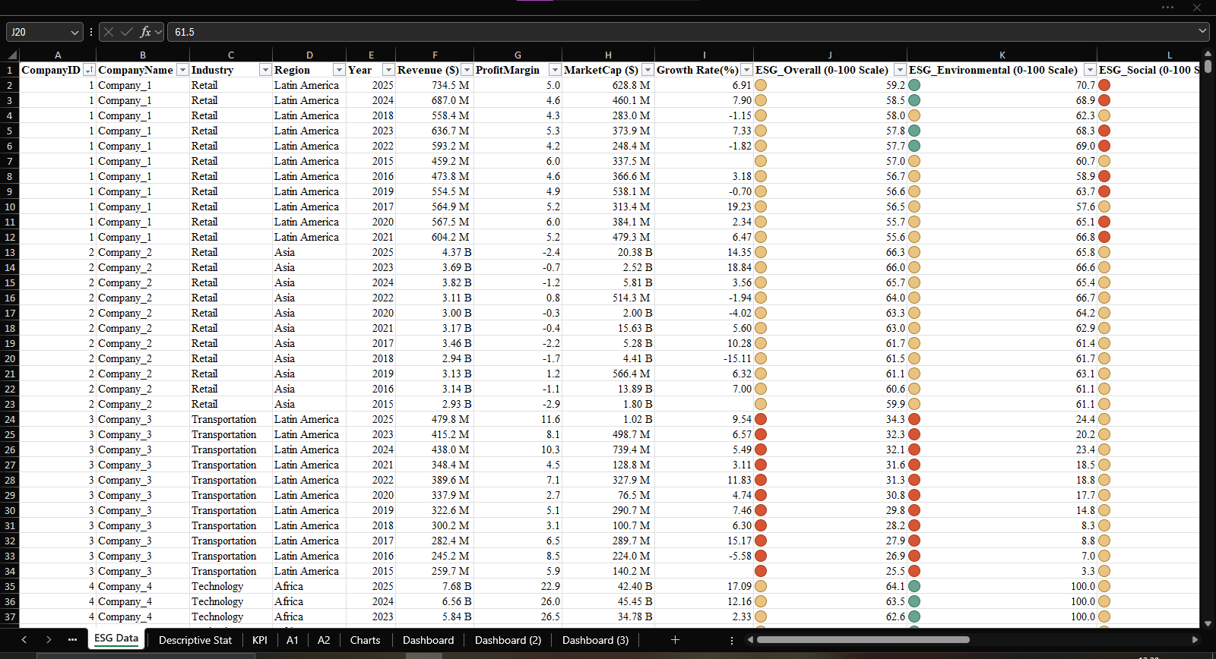

**EXPLORATORY DATA ANALYSIS (EDA)**

**Pivot Analysis**

- Region-wise and industry-wise averages

- Industry grouped ESG scores vs profit margin/market cap

- Market Value and Profit Margin Distribution vs ESG scores by Industry

- Company ESG Overall Scores and Profit Margin

**KPI’s**

KPIs were added for dashboard tracking: These KPIs were selected to provide a well-rounded view of company and industry performance, balancing ESG sustainability metrics with financial and market-based indicators. Together, they support investor decision-making by revealing where ESG and business success align most clearly.

| **KPI** | **Result** | **Description** |
| --- | --- | --- |
| **Average ESG_Overall Score** | 54.6 | Companies' overall ESG performance |
| **Average Profit Margin** | 10.9% | Overall profitability across companies |
| **Average Market Cap** | $13.38 billion | Investor value perception |
| **Average Growth Rate** | 4.83% | Revenue growth performance |
| **Company Count** | 1,000 companies | Total dataset coverage |

**Average ESG_Overall Score:** Shows how well the industries are doing in terms of sustainability and how well they are integrating environmental, social and governance practices

**Average Profit Margin:** Shows how well the companies turn revenue into profit across industries

**Average Market Cap:** shows how the market values or perceives the industries

**Average Growth Rate:** Shows the momentum and future potential of industries, how well the industries grew

**Descriptive Statistics**

These statistics describe the overall distribution of important fields like Revenue, Profit Margin, Market Cap, Growth Rate, and ESG Scores.

| **Statistic** | **Meaning** |
| --- | --- |
| **Minimum (MIN)** | The lowest value observed in the data. Shows the worst or smallest case (e.g., lowest revenue, lowest ESG score). |
| **Maximum (MAX)** | The highest value observed. Shows the best or largest case (e.g., highest profit margin, highest ESG score). |
| **Median** | The middle value when all data points are ordered. It’s less affected by extremely high or low values (outliers). |
| **Mean (Average)** | The sum of all values is divided by the number of companies. Gives an overall average. |
| **Standard Deviation** | Measures on how spread out the numbers are from the mean. A **high standard deviation** means values are spread out; a **low standard deviation** means they are close to the average. |

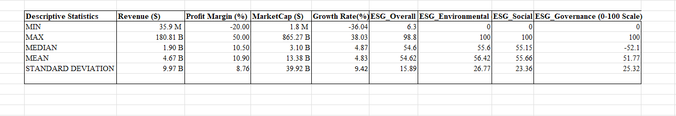

1. Revenue ($)

Min: $35.9M / Max: $180.81B – Company sizes range from very small to massive multinationals.

Median: $1.90B – Half of the companies earn below this; indicates typical company size.

Mean: $4.67B – Average revenue is skewed higher due to a few very large firms.

Standard Deviation: $9.97B – High variation in company revenue.

1. Profit Margin (%)

Min: -20.00 / Max: 50.00 – Some firms are deeply unprofitable, others highly profitable.

Median: 10.5% / Mean: 10.9% – Most companies maintain healthy profit levels.

Std. Dev: 8.76% – Moderate spread in profitability across companies.

**3**. Market Cap ($)

Min: $1.8M / Max: $865.27B – From micro-cap to mega-cap companies.

Median: $3.10B – Most companies are mid-cap.

Mean: $13.38B – Pulled up by a few very large firms.

Std. Dev: $39.92B – Wide variation in market valuation.

1. Growth Rate (%)

Min: -36.04 / Max: 38.03 – Some firms are shrinking fast; others are growing rapidly.

Median: 4.87% / Mean: 4.83% – Most companies grow moderately each year.

Std. Dev: 9.42% – Significant differences in growth rates across firms.

1. ESG_Overall (0–100 Scale)

Min: 6.3 / Max: 98.8 – Very wide range in ESG performance.

Median & Mean: ~54.6 – ESG scores are fairly centered.

Std. Dev: 15.89 – Moderate variability in overall ESG scores.

1. ESG_Environmental

Min: 0 / Max: 100 / Mean: 56.42 – Broad range; many companies excel or fail here.

Std. Dev: 26.77 – High variation in environmental performance.

1. ESG_Social

Min: 0 / Max: 100 / Mean: 55.66 – Social performance also varies widely.

Std. Dev: 23.36 – Considerable differences across companies.

1. ESG_Governance

Min: 0 / Max: 100 / Mean: 51.77 – Governance scores tend to be lower overall.

Std. Dev: 25.32 – High variation; some firms are very weak, others strong.

**ANALYSIS**

Analysis Questions

1. What is the correlation between overall ESG scores and financial metrics like profit margin and market cap?

2. Which ESG factor most strongly influences industry valuation?

3. What are the Top 3 Valuable Industries?

4. Which industries combine high ESG and strong performance?

5. Which regions show the best blend of ESG and financial strength?

**Approach**

- Correlation analysis

- Ranking & segmentation

- Group averages by industry and region

- Chart visualizations: bar charts, Column Charts, Table views, scatter plots

**Findings**

1. What is the correlation between overall ESG scores and financial metrics like profit margin and market cap?

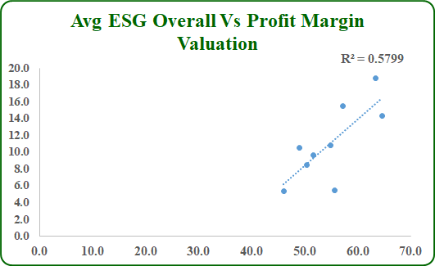

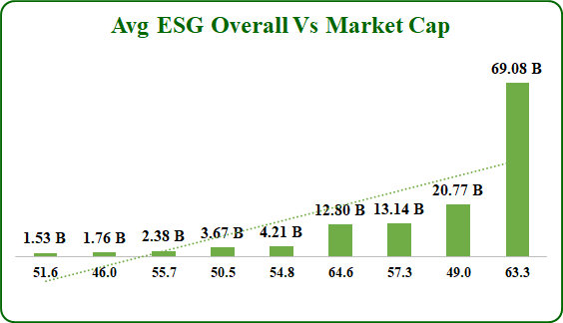

- **Correlation** tells us how closely two things move together (and in what direction).

Correlation coefficient *r* measures how strongly two variables are related: ranges from **-1 to +1** (shows direction and strength).

* **1** = Perfect positive linear relationship (if one goes up, the other goes up).
* **-1** = Perfect negative linear relationship (if one goes up, the other goes down).
* **0** = No linear relationship.

**Regression** (R²) tells us how much of the change in one thing is explained by the other.

**Regression** emphasizes how much of the variation in the dependent variable is explained by the independent variable.

* **R² = 0** means the model explains none of the variance.
* **R² = 1** means the model explains all the variance.

R² simply expresses how much of the variance in Y is explained by X, while the Pearson correlation shows the strength and direction of the linear relationship.

**ESG Overall vs. Profit Margin & Market Cap**

* **Profit Margin**: **0.76** (Strong positive relationship)  
  → The correlation between ESG scores and profit margin is strong and positive (r = 0.76), indicating that higher ESG scores are associated with **higher profit margins**. Moreover, ESG scores explain about 58% of the variability in profit margin (R² = 0.58)
* **Market Cap**: **0.55** (Moderate positive relationship)  
  → The correlation between ESG scores and market value is moderate and positive (r = 0.76), indicating that industries with higher ESG scores tend to have **larger market sizes**.
  1. Which ESG factor strongly influences industry valuation?

According to the correlation table, the results show

**ESG Environmental vs. Market Cap had the highest value**

* **Market Cap**: **0.57** (Moderate positive relationship)  
  → The correlation between ESG Environmental scores and market value is moderate and positive (r = 0.57), indicating that industries with **higher** **environmental** scores generally tend to be **larger** **in size**..

3. What are the Top 3 Valuable Industries?

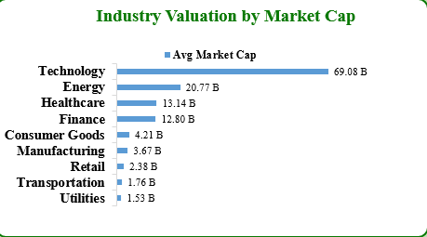

**Top 3 Industries by Market Cap**

According to the chart, it shows the following industries as the top 3

• **Technology** – 69.08 B

• **Energy** – 20.77 B

• **Healthcare** – 13.14 B

4. Which industries combine high ESG and strong performance?

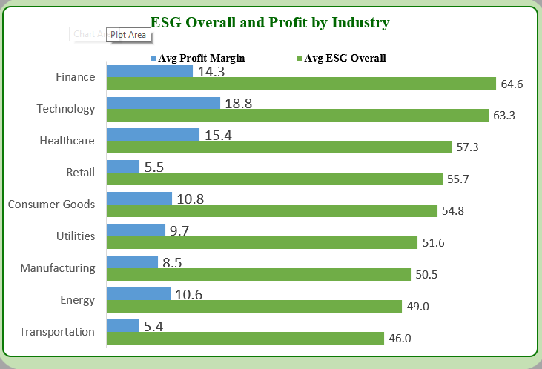

From the data, the standout industries that balance above-average ESG scores (50-100 scale) with strong profitability are:

**1. Technology**

* ESG: 63.3 (2nd highest)
* Profit Margin: 18.8% (highest)

**2. Finance**

* ESG: 64.6 (highest)
* Profit Margin: 14.3% (3rd highest)

**3. Healthcare**

* ESG: 57.3 (3rd highest)
* Profit Margin: 15.4% (2nd highest)

Technology, Finance, and Healthcare are the best at merging sustainability with profitability. Industries in these sectors prove ESG doesn’t require sacrificing margins.

5. Which regions show the best blend of ESG and financial strength?

From the data, the top-performing regions that combine **high ESG scores** with **competitive profit margins** are:

**1. Europe**

* **ESG: 67.9** (highest globally)
* **Profit Margin: 10.3%** (moderate but stable)

**2. Oceania**

* **ESG: 62.4** (2nd highest)
* **Profit Margin: 10.8%** (above Europe)

**3. North America**

* **ESG: 61.2** (3rd highest)
* **Profit Margin: 11.3%** (highest among top ESG regions)

**SUMMARY OF ANALYSIS/RESULTS**

**Summary of Findings**

**1a. Relationship Between ESG Scores and Profit Margin**

I found that industries with higher ESG scores tend to have higher profit margins. The connection is quite strong (correlation = 0.76), which means as ESG scores go up, profit margins usually go up too.

Also, about 58% of the differences in profit margins across industries can be explained by their ESG scores (R² = 0.58). This shows that ESG performance plays a big role in financial results.

**1b. Relationship Between ESG Scores and Market Cap**

For market value, the connection is moderate. Companies with higher ESG scores generally tend to be larger, but the relationship isn’t perfect.

Overall, about 57% of the differences in industry size can be linked to their ESG scores, which shows ESG performance has a noticeable impact, though other factors also play a role

**2. ESG factor with the most influence on Industry Value**

Industries with better environmental scores tend to have higher overall value. The connection isn’t perfect, but there is a clear positive link between strong environmental practices and larger market size.

**3. The three most valuable Industries**

The Technology sector has the largest market capitalization at 69.08 billion, followed by the Energy sector at 20.77 billion and the Healthcare sector at 13.14 billion. These three industries together account for the majority of the total market value across all sectors analyzed.

**4. High performing industries with high ESG scores**

From the data, Technology, Finance, and Healthcare Industries stand out for doing the best job combining strong sustainability with good profits. These industries have some of the highest ESG scores while earning healthy profit margins, showing that being responsible doesn’t mean making less money.

**5. High financial performance by region**

Europe, Oceania, and North America show the best balance of high ESG scores and solid profits. These regions lead in combining strong sustainability practices with healthy financial performance.

**VISUALIZATIONS**

- Page 1 Dashboard :

1. ESG Overall vs Profit Margin (Scatter Chart)

2. ESG Overall vs Market Cap (Bar Chart)

3. ESG Pillars Vs Market Cap Comparison (Bar Chart)

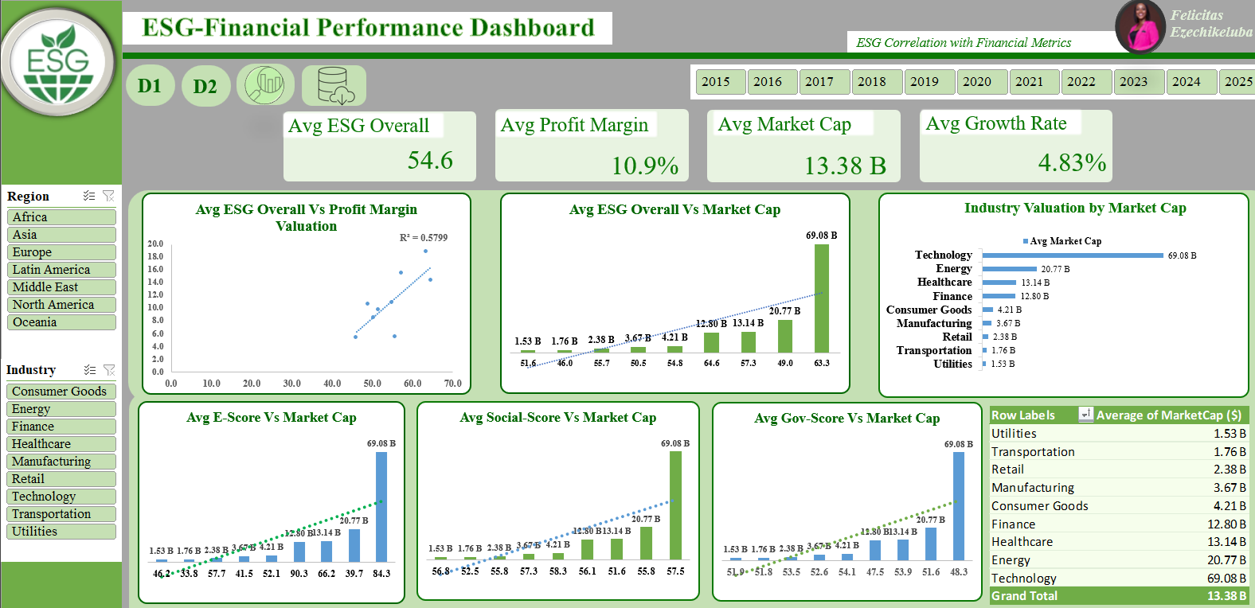

- Page 2 Dashboard:

1. ESG Overall & Profit by Industry (Grouped Bar)

2. ESG Overall & Profit by Region (Grouped Bar)

**DISCUSSION**

**Interpretation of Results**

The analysis reveals important insights into how ESG performance connects to profitability and market value across industries and regions.

Industries with stronger ESG scores tend to enjoy better profit margins. The relationship is quite strong (correlation = 0.76), meaning that as ESG scores rise, profit margins generally improve. About 58% of the differences in profit margins across industries can be linked to ESG scores. This suggests that sustainability practices are often aligned with financial success, rather than being a cost.

Technology, Finance, and Healthcare stand out as industries that strike the best balance between ESG leadership and profitability.

* **Technology** combines high ESG performance (63.3) with the highest profit margin (18.8%).
* **Finance** leads in ESG (64.6) while maintaining a solid 14.3% profit margin.
* **Healthcare** has the second-highest profit margin (15.4%) and strong ESG (57.3).

These industries demonstrate that integrating ESG into operations does not have to come at the expense of profitability, in fact, it often supports it..

Other industries, like **Consumer Goods** (ESG 54.8 | profit margin 10.8%), **Energy** (ESG 49.0 | 10.6%), and **Utilities** (ESG 51.6 | 9.7%) perform moderately on both ESG and profitability. Meanwhile, **Transportation** (46.0 | 5.4%) and **Retail** (55.7 | 5.5%) show that higher ESG doesn’t always translate into higher profits in every sector. This could reflect tighter margins or greater operational challenges in these industries.

When looking at market value, the connection with ESG scores is moderate rather than strong (correlation = 0.57 for Environmental ESG vs. market cap). This means industries with higher environmental scores tend to be larger, but other factors influence size too.

The top industries by market cap are:

1. **Technology** – 69.08 B
2. **Energy** – 20.77 B
3. **Healthcare** – 13.14 B

While these industries with higher ESG ratings also tend to be larger in size, other sectors such as Finance, despite the high ESG profitability, has a smaller market cap (12.80 B) compared to Technology and Energy. This could be due to the concentration of large-cap tech and energy firms dominating the market, or different capital structures and investor perceptions in the finance sector. It also suggests that factors like sector growth potential, competitive dynamics, and capital requirements also play an important role in shaping industry size. Similarly, sectors like Transportation, Utilities, and Retail have smaller market values, reflecting market size, competition, and sector-specific growth limits.

At the regional level, Europe, Oceania, and North America show the best balance of high ESG scores and stable profit margins, with Europe leading globally in ESG performance (67.9) with stable profit margins (10.3%) and Oceania and North America follow, combining strong ESG with slightly higher profits (10.8% and 11.3%). This shows these regions manage to align sustainability with financial strength.

These regions may benefit from stronger regulations, investor expectations, and market conditions that encourage sustainable practices alongside financial strength. In contrast, other regions such as Asia, Africa, and Latin America report moderate ESG scores (44–52) but still maintain competitive profit margins (10.4%–11.4%). This reflects different regulatory and business environments, market priorities across the globe, or resource-based economies where profitability is driven by traditional industries rather than ESG focus.

The results show that industries like Technology, Finance, and Healthcare prove ESG can support both reputation and financial returns. However, ESG’s financial impact varies by sector, some industries face greater challenges balancing sustainability with profitability. Regional differences highlight that ESG leadership is strongest in Europe, but North America offers a compelling mix of sustainability and higher profits.

Overall, the results indicate that ESG performance can be a meaningful driver of both profitability and investor confidence across many industries and regions. However, the impact varies depending on sector characteristics and market factors. For investors, this suggests that considering ESG metrics alongside industry trends and regional contexts can provide a more complete picture of financial potential.

**RECOMMENDATIONS**

1. **For Businesses**:
   * Focus on **ESG areas with financial returns** (e.g., energy efficiency in manufacturing).
   * Avoid **over-investing in governance** if it hurts profits (unless required by law).
   * **Focus on Environmental Practices to Enhance Market Value:** Since Environmental ESG scores have the strongest link to market capitalization, industries aiming to improve investor perception and long-term valuation should prioritize environmental improvements, such as reducing emissions and adopting clean technologies.
   * **Tailor ESG Strategies by Region**  
     Europe leads in ESG performance, but North America offers a strong balance of ESG and higher profitability. Companies operating across regions should adapt their ESG approaches to local expectations and regulations to maximize both financial and reputational benefits.
2. **For Investors**:
   * Target **high-ESG industries** (tech, finance) in **Europe/North America**.
   * Avoid **low-ESG sectors** (e.g., coal) due to future regulatory risks.
   * **Consider ESG Factors in Investment Decisions**  
     Investors should integrate ESG metrics into their evaluation frameworks, especially when assessing sectors like Technology, Finance, and Healthcare, where sustainability is clearly linked to stronger financial performance.

**LIMITATIONS**

- Time-series variation not deeply analyzed

- External factors (regulations, global events) not considered

- Excel functionality limits deeper statistical testing

**CONCLUSION**

The analysis shows that ESG performance is not only a measure of corporate responsibility but also a meaningful indicator of financial strength across industries and regions. Sectors such as Technology, Finance, and Healthcare demonstrate that strong sustainability practices often align with higher profit margins and greater market value. While the impact of ESG varies by industry, region, and strategy, the overall trends suggest that integrating environmental, social, and governance considerations can support long-term profitability and enhance investor confidence.

ESG isn’t a profit-killer, it depends on how it is applied. The best approach is to balance sustainability with financial goals, using top performers like the Technology sector and regions such as Europe as benchmarks. For businesses, the findings highlight the value of embedding ESG into strategy without losing focus on financial discipline. For investors, considering ESG metrics alongside traditional financial indicators can provide a more complete view of potential risks and opportunities.

Overall, ESG has emerged as an important factor shaping both company performance and market perception.